Project Planning Phase

Project Planning Template

Product Backlog, Sprint Planning, Stories & Story Points
Details | Information
Date | 15 February 2025
Team ID | __________
Project Name | Online Event Management System
Maximum Marks | 5 Marks

1. Product Backlog, Sprint Schedule and Estimation

Story Point Scale
Story Points | Difficulty
1 | Very Easy
2 | Normal
3 | Moderate
5 | Difficult

Product Backlog
Sprint | Functional Requirement (Epic) | User Story Number | User Story / Task | Story Points | Priority | Team Members
Sprint-1 | Registration | USN-1 | As a participant, I can register for the application using my name, email and password. | 3 | High | __________
Sprint-1 | Registration | USN-2 | As a participant, I can receive confirmation after successful registration. | 2 | High | __________
Sprint-1 | Login | USN-3 | As a participant, I can log into the application using my email and password. | 2 | High | __________
Sprint-1 | Profile Management | USN-4 | As a participant, I can view and update my profile information. | 2 | Medium | __________
Sprint-1 | Event Management | USN-5 | As a participant, I can view available events with their details. | 2 | High | __________
Sprint-1 | Event Management | USN-6 | As an event organizer, I can create a new event. | 3 | High | __________
Sprint-1 | Event Management | USN-7 | As an event organizer, I can update event details. | 3 | High | __________
Sprint-1 | Event Management | USN-8 | As an event organizer, I can delete an event. | 2 | Medium | __________
Sprint-1 | Participant Management | USN-9 | As a participant, I can register for an available event. | 3 | High | __________
Sprint-2 | Payment | USN-10 | As a participant, I can make an online payment for a paid event. | 5 | High | __________
Sprint-2 | Payment | USN-11 | As a participant, I can receive payment confirmation. | 2 | Medium | __________
Sprint-2 | Participant Management | USN-12 | As an event organizer, I can view participants registered for my events. | 3 | High | __________
Sprint-2 | Participant Management | USN-13 | As an event organizer, I can manage registered participants. | 3 | Medium | __________
Sprint-2 | User Management | USN-14 | As an administrator, I can view and manage user accounts. | 3 | High | __________
Sprint-2 | Event Management | USN-15 | As an administrator, I can manage all events. | 3 | High | __________
Sprint-2 | Registration Management | USN-16 | As an administrator, I can view and manage event registrations. | 2 | High | __________
Sprint-2 | Dashboard | USN-17 | As an administrator, I can view a dashboard containing users, events and registrations. | 5 | Medium | __________
Sprint-2 | Reports | USN-18 | As an administrator, I can generate event and registration reports. | 3 | Medium | __________

Sprint totals
Sprint-1:
3 + 2 + 2 + 2 + 2 + 3 + 3 + 2 + 3 = 22 Story Points
Sprint-2:
5 + 2 + 3 + 3 + 3 + 3 + 2 + 5 + 3 = 29 Story Points
Total = 22 + 29 = 51 Story Points

2. Project Tracker, Velocity & Burndown Chart
I recommend using two 6-day sprints, which keeps this simple and matches the type of sprint schedule in your faculty template.
Sprint | Total Story Points | Duration | Sprint Start Date | Sprint End Date (Planned) | Story Points Completed | Sprint Release Date (Actual)
Sprint-1 | 22 | 6 Days | 17 Feb 2025 | 22 Feb 2025 | 22 | 22 Feb 2025
Sprint-2 | 29 | 6 Days | 24 Feb 2025 | 01 Mar 2025 | 29 | 01 Mar 2025
If your faculty has given you specific sprint dates, replace these dates with those dates. The story points and calculations can remain the same.

3. Velocity

Total Story Points
Sprint-1 = 22
Sprint-2 = 29
Total Story Points = 22 + 29 = 51

Team Velocity
The average velocity is:
Velocity = Total Story Points Completed ÷ Number of Sprints
Velocity = 51 ÷ 2

Average Velocity = 25.5 Story Points per Sprint
You can write:
The team's average velocity is 25.5 Story Points per Sprint.
If your college requires a whole number, you can state it as approximately 26 Story Points per Sprint.

4. Average Velocity per Day
Since each sprint has 6 days:
Average velocity per day = 25.5 ÷ 6
= 4.25 Story Points per day
Therefore:
Average velocity = 4.25 Story Points per day.

5. Burndown Chart
A burndown chart shows the remaining work (story points) against the number of sprint days.
For your project:
- Starting work = 51 Story Points
- Completed work = 51 Story Points
- Remaining work = 0 Story Points
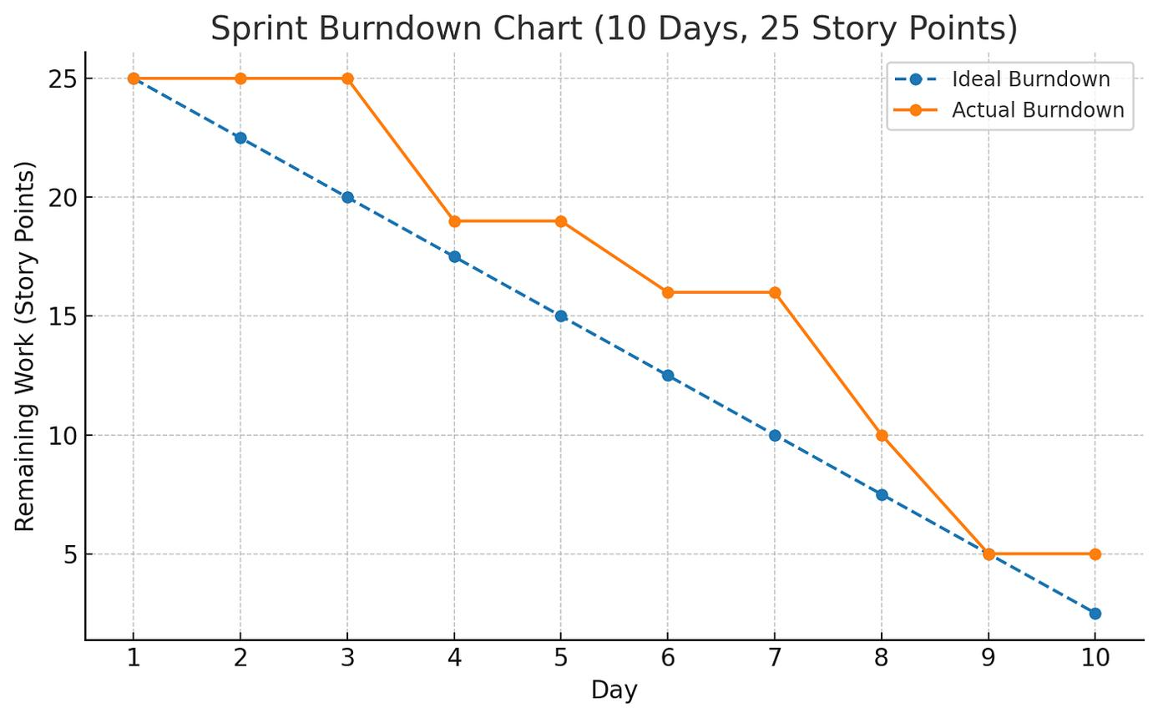
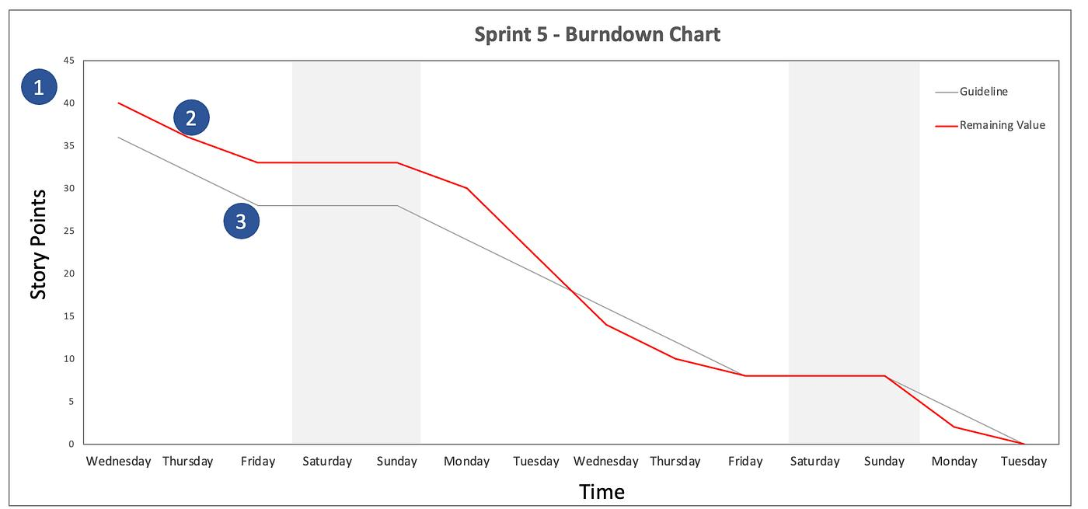
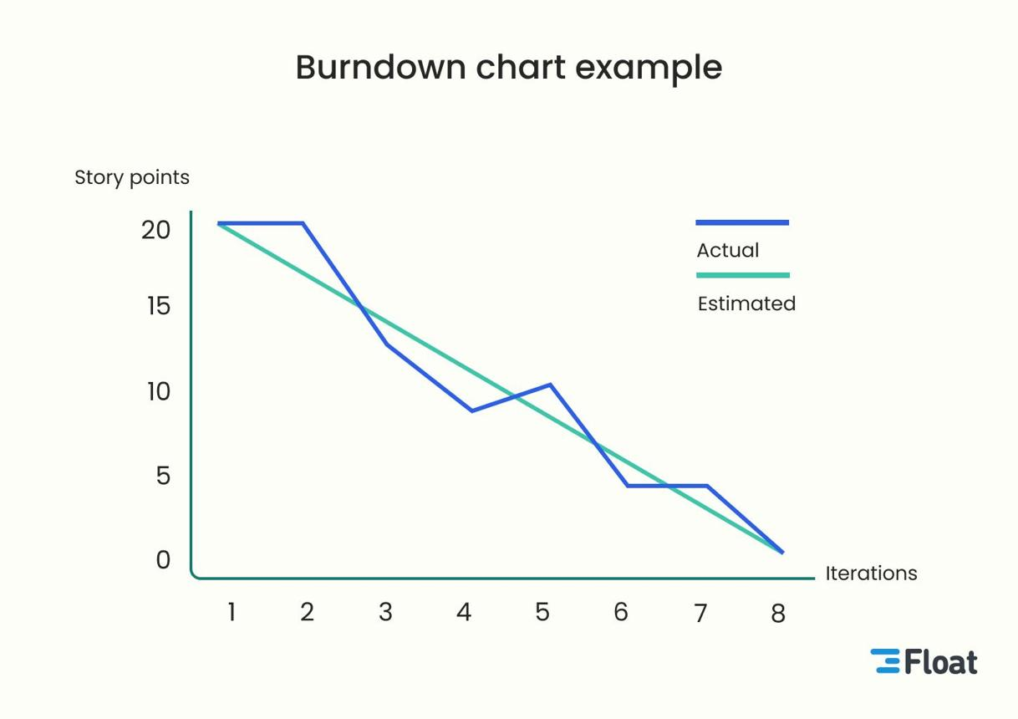
4
I also created a burndown chart specifically for your Online Event Management System:
Download the Online Event Management System Burndown Chart

Burndown data you can enter
Day | Story Points Remaining
0 | 51
1 | 47
2 | 43
3 | 39
4 | 35
5 | 31
6 | 26
7 | 22
8 | 17
9 | 12
10 | 7
11 | 3
12 | 0

